

NATIONAL INSTITUTE OF TECHNOLOGY KARNATAKA

SURATHKAL, MANGALORE - 575 025

Course Code – CS111

Course Name – Computer Programming Lab

Lab - 04

Date – June 8, 2021

Submitted To

Marwa Mohiddin Ma’am

Department of Computer Science and Engineering

National Institute of Technology Karnataka, Surathkal

Submitted By

Md Rakib Hasan

Roll – 201CS132

Department of Computer Science and Engineering

**Arrays**

**Question – 1**

To read an array of N elements and reverse it

**Answer**

#include<stdio.h>

int main()

{

    int n, i;

    printf("Total number in the array: ");

    scanf("%d", &n);

    int arr[n];

    printf("Enter the element of array: ");

    for(i=0; i<n; i++)

    {

        scanf("%d", (arr+i));

    }

    printf("Reverse array: ");

    for(i=n-1; i>=0; i--)

    {

        printf("%d ", *(arr+i));

    }

    return 0;

}

**Output**

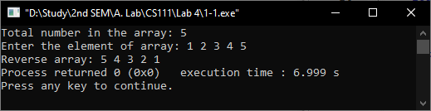

**Question – 2**

Program to count the number of palindromes in a given list of n numbers

**Answer**

#include<stdio.h>

int main()

{

    int n, i, temp, rem, rev, count=0;

    printf("Total number in list: ");

    scanf("%d", &n);

    int arr[n];

    printf("Enter the numbers: ");

    for(i=0; i<n; i++)

    {

        scanf("%d", (arr+i));

        //palindromes check

        temp = *(arr+i);

        rev = 0;

        while(temp != 0)

        {

            rem = temp % 10;

            rev = (rev*10) + rem;  //reversed number

            temp /= 10;

        }

        if((*(arr+i) == rev) || *(arr+i) == 0)

        {

            count++;

        }

    }

    printf("Total palindrome = %d", count);

    return 0;

}

**Output**

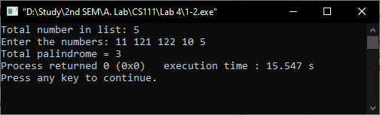

**Question – 3**

Find the pair of numbers in an unsorted array such that their sum is the largest

**Answer**

#include<stdio.h>

int main()

{

    int n, i, j, sum=0, num1, num2;

    printf("Enter total number: ");

    scanf("%d", &n);

    int arr[n];

    printf("Enter array element: ");

    for(i=0; i<n; i++)

    {

        scanf("%d",(arr+i));

    }

    for(i=0; i<n-1; i++)

    {

        for(j=i+1; j<n; j++)

        {

            if(sum < (*(arr+i)+*(arr+j)))  //largest sum

            {

                sum = (*(arr+i)+*(arr+j));

                num1 = *(arr+i);

                num2 = *(arr+j);

            }

        }

    }

    printf("Largest sum = %d from num: %d & %d", sum, num1, num2);

    return 0;

}

**Output**

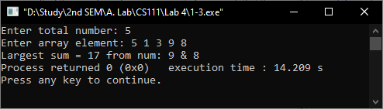

**Strings**

**Question – 1**

To read a string and find its length without using a library function

**Answer**

#include<stdio.h>

#define MAX_SIZE 1000

int main()

{

    char str[MAX_SIZE];

    printf("Enter a staring: ");

    scanf("%[^\n]%*c", str);  // take input until new line

    int i=0, len=0;

    while(str[i] != '\0')  //null character

    {

        len++;

        i++;

    }

    printf("Length of string = %d", len);

    return 0;

}

**Output**

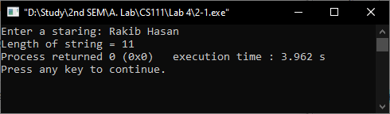

**Question – 2**

To reverse a string and check whether the string is palindrome or not

**Answer**

#include<stdio.h>

#include<string.h>

#define MAX_SIZE 1000

int main()

{

    char str[MAX_SIZE];

    printf("Enter your string: ");

    scanf("%[^\n]%*c", str);

    int i, len, res=1;

    len = strlen(str);   //length of string

    for(i=0; i<len; i++)

    {

        if(str[i] != str[len-1-i])

        {

            res = 0;

            break;

        }

    }

    if(res==1)

    {

        printf("Palindrome");

    }

    else

    {

        printf("Not Palindrome");

    }

    return 0;

}

**Output**

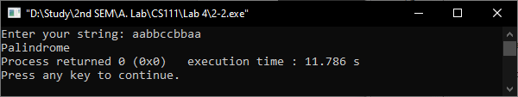

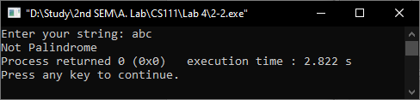

**Question – 4**

Program to replace lowercase characters by uppercase & vice-versa

**Answer**

#include<stdio.h>

#include<string.h>

#define MAX_SIZE 1000

int main()

{

    char str[MAX_SIZE], temp;

    printf("Enter string: ");

    scanf("%[^\n]%*c", str);

    int i, len;

    len = strlen(str);

    printf("Output: ");

    for(i=0; i<len; i++)

    {

        temp = *(str+i);

        if(temp>= 'a' && temp<='z')

        {

            str[i] = temp-32;  // a-32 = A (ASCII)

        }

        else if(temp>= 'A' && temp<='Z')

        {

            str[i] = temp+32;  // A+32 = a (ASCII)

        }

        printf("%c", *(str+i));

    }

    return 0;

}

**Output**

